SALES ANALYTICS

END-TO-END SALES ANALYTICS PROJECT

NAME: R. KAMALENDRAN
Git repo link: https://github.com/kamalendran464-byte/Sales-Analysis-Report-.git

Project Overview
The objective of this project is to develop an end-to-end Sales Analytics solution that helps a business understand its sales performance, customer behavior, product performance, regional sales, profitability, and overall business growth.
The project covers the complete analytics lifecycle, starting from raw sales data and ending with an interactive Power BI dashboard and actionable business recommendations.

Tools and Technologies
The following tools will be used:
- Google Co-Lab – Data exploration and initial cleaning, Data extraction, transformation, and analysis
- SQL – performing some query
- Power BI – Dashboard development
- GitHub – Project documentation and portfolio

Dataset structure
Your Excel file contains 4 tables:
Table | Rows | Columns | Purpose
Sales Orders | 7,991 | 12 | Main transaction/fact table
Customers | 50 | 2 | Customer master
Regions | 100 | 7 | Delivery/location master
Products | 15 | 2 | Product master

Data Model
Table | Role | Important Fields
Sales Data | Fact / transaction table | Order Number, Order Date, Quantity, Unit Selling Price, Unit Cost, Sales, Profit, Channel
Customer Data | Customer dimension | Customer Index, Customer Names
Products Data | Product dimension | Product Index, Product Name
Regions Table | Geography dimension | Index, City, Suburb, postcode, Address, Latitude, Longitude
DateTable | Date dimension | Date, Year, Month, Month Sort, Month-Year
Measure Table | Measures | Sales, Sales PY, Sales vs PY, Profit, Profit LY, Profit Margin

Data Relationship
The datasets were connected using common identifiers such as Sales Orders Customer Name Index ,Order Number , Order Date ,Ship Date, source and hiring-outcome information to be combined for end-to-end recruitment analysis.
Integrated Dataset
The final integrated dataset contains 7,991 sales transaction-level records and 31 columns. The dataset combines information from sales orders, customers, products, and regions into a single analytical structure. Derived features were also created to support sales, profitability, customer, product, and regional performance analysis.
Data Area | Representative Fields
Sales Order | Order Number, Order Date, Ship Date, Channel, Currency Code, Warehouse Code, Order Quantity, Unit Selling Price, Unit Cost
Customer | Customer Index, Customer Name Index, Customer Names
Product | Product Description Index, Product Name
Region | Delivery Region Index, Suburb, City, postcode, Longitude, Latitude, Full Address
Sales Metrics | Sales Amount, Cost Amount, Profit, Profit Margin %
Time Features | Order Year, Order Month, Order Month Name, Order Quarter
Derived Features | Sales Amount = Order Quantity × Unit Selling Price, Cost Amount = Order Quantity × Unit Cost, Profit = Sales Amount − Cost Amount, Profit Margin %

Dataset Summary
- Records: 7,991
- Columns: 31
- Granularity: Individual sales order/transaction
- Main Fact: Sales Orders
- Dimension Areas: Customer, Product, Region, Date
- Analysis Areas: Sales, Cost, Profit, Margin, Quantity, Customer, Product, Region, Channel, and Time

. Key Business Measures
Measure | Purpose
Sales | Measures revenue generated from sales transactions.
Sales PY | Compares current sales with the previous-year sales value.
Sales vs PY | Shows the variance or comparison between current sales and previous-year sales.
Profit | Measures sales value after deducting the associated cost.
Profit LY | Provides previous-year profit for historical comparison.
Profit Margin | Shows profitability relative to sales.
Google co-lab
Step 1: Analysis the data using with google co-lab
Upload the dataset to Google Co-lab (xlsl or csv )
uploaded = files.upload()
Select: Integrated_Sales_Dataset.xlsx
Read the data :
df = pd.read_excel('Sales Analysis Report.xlsx')
show the data :
df.head()
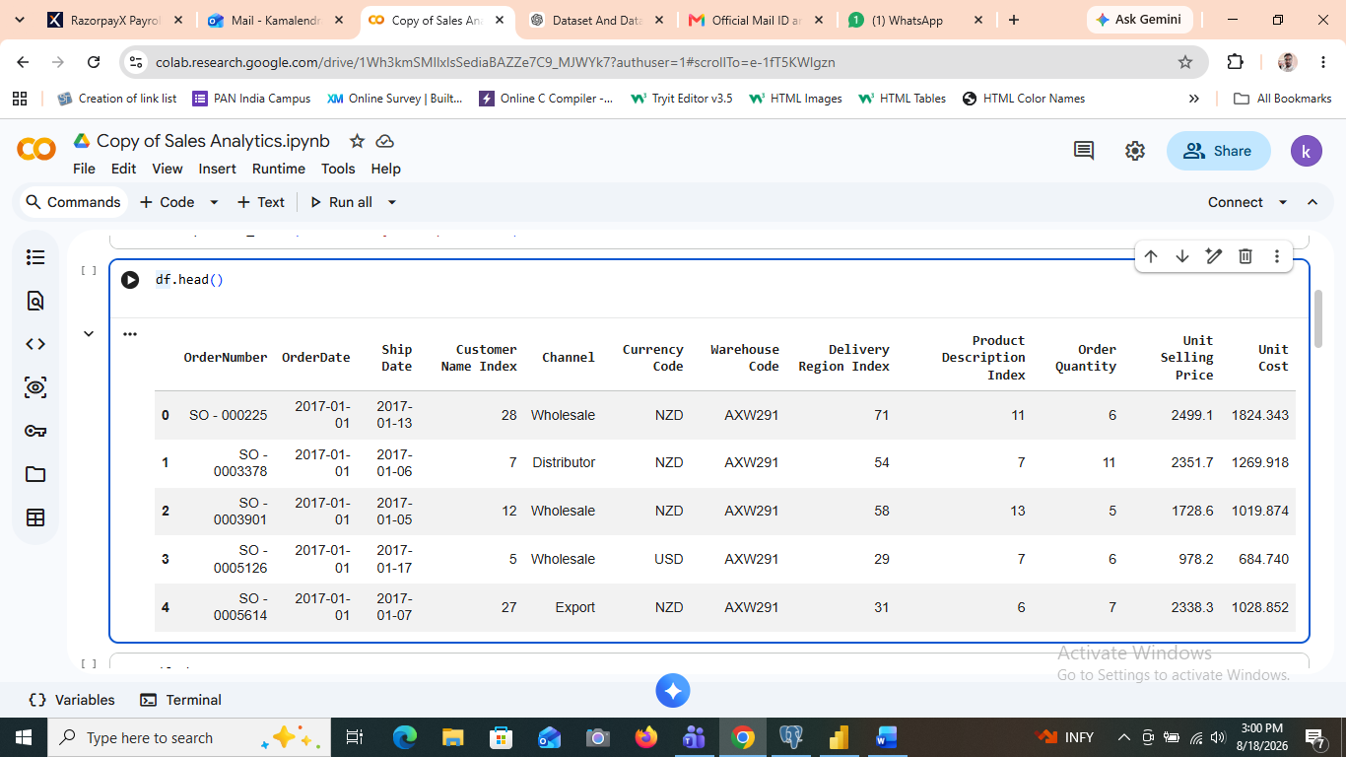

Display all column names
df.columns()
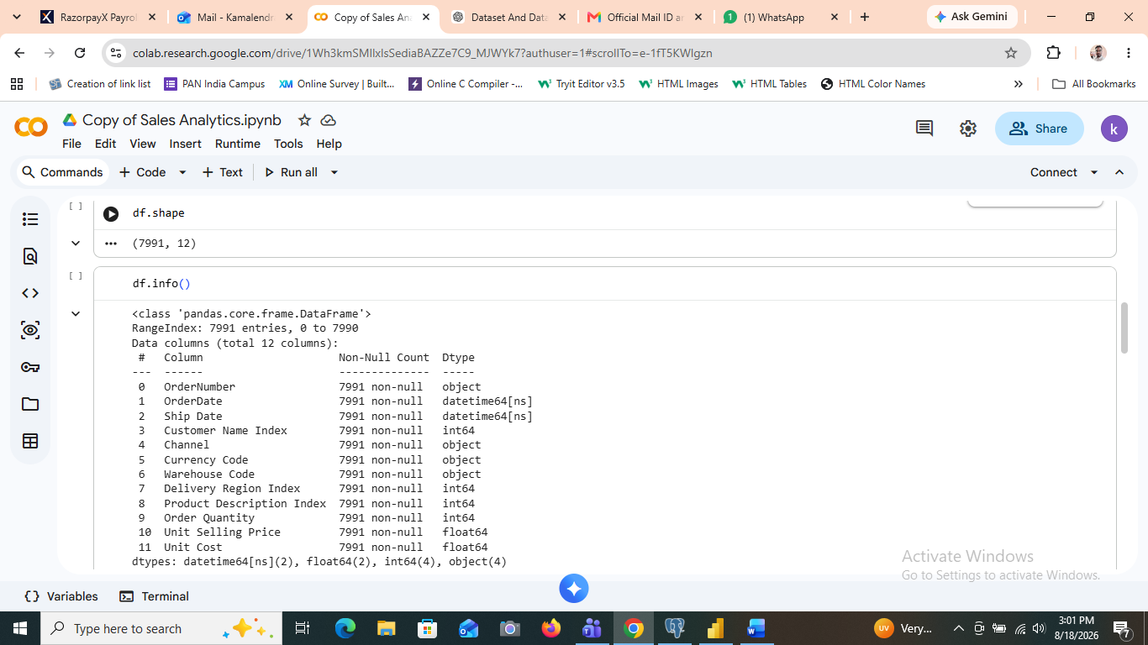
Check data types:
df.info()


df.isnull().sum()
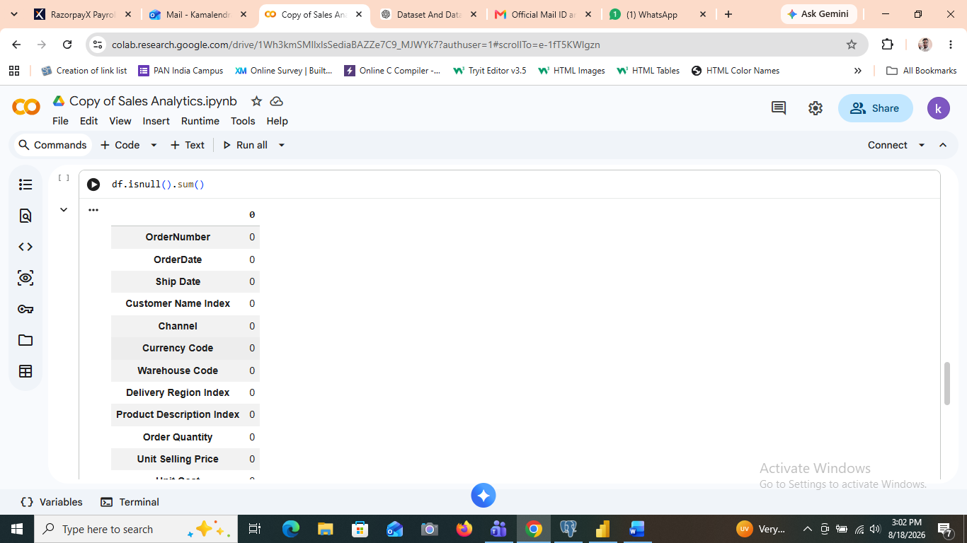
Total unit selling price:
df.["unit selling price"].sum()

Download the cleaned CSV file from Colab
from google.colab import files
files.download("Cleaned_Sales_Dataset.csv")

Step 2: Upload clean csv file into pgadmin data base
Create database in pgAdmin
Open pgAdmin → Servers → PostgreSQL → Databases
For example:
Database Name: sales analysis
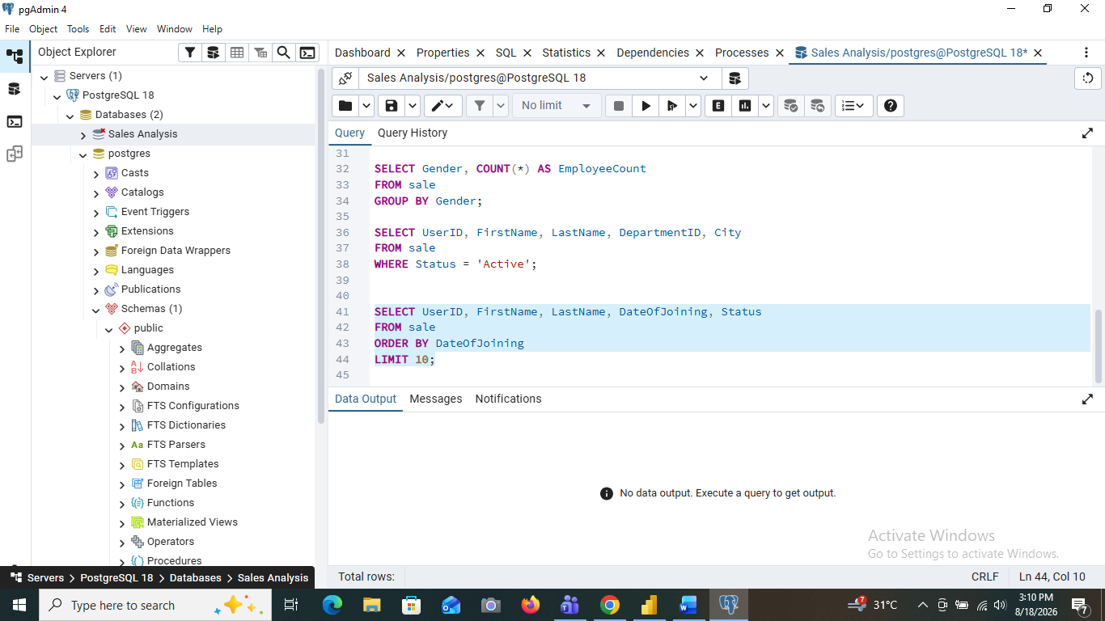
2. Create the table
Query Tool create table and run:
CREATE TABLE Sale (
UserID VARCHAR(20),
EmployeeCode VARCHAR(20),
FirstName VARCHAR(100),
LastName VARCHAR(100),
Gender VARCHAR(20),
DepartmentID VARCHAR(20),
RoleID VARCHAR(20),
City VARCHAR(100),
state VARCHAR(100),
Country VARCHAR(100),
Email VARCHAR(255),
Phone VARCHAR(20),
DateOfJoining DATE,
EmploymentType VARCHAR(50),
Status VARCHAR(50)
);
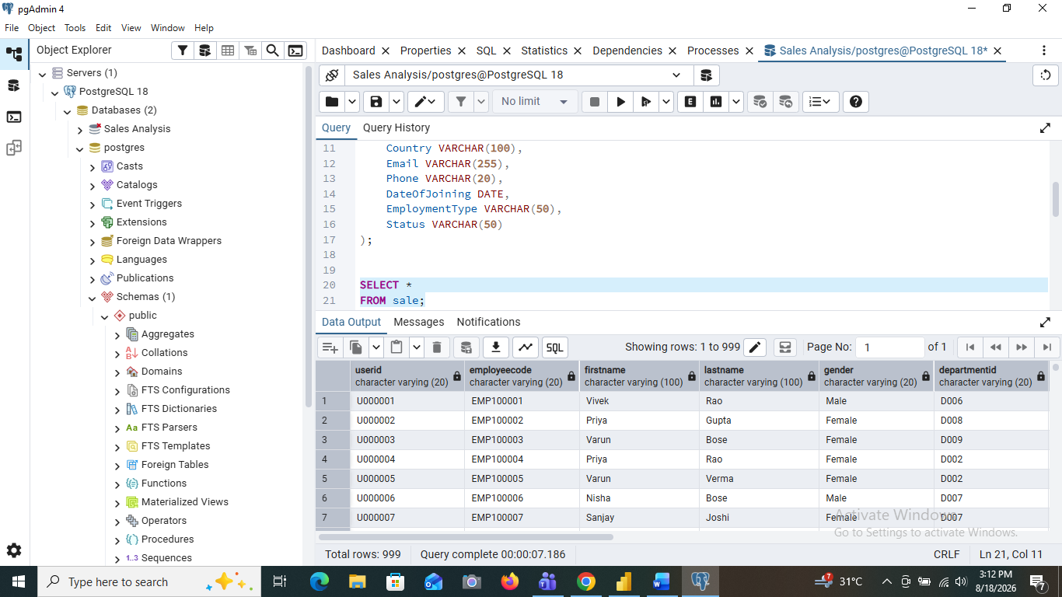

SELECT * FROM sale;


SELECT UserID, FirstName, LastName, City, Status
FROM sale
WHERE City = 'Chennai';
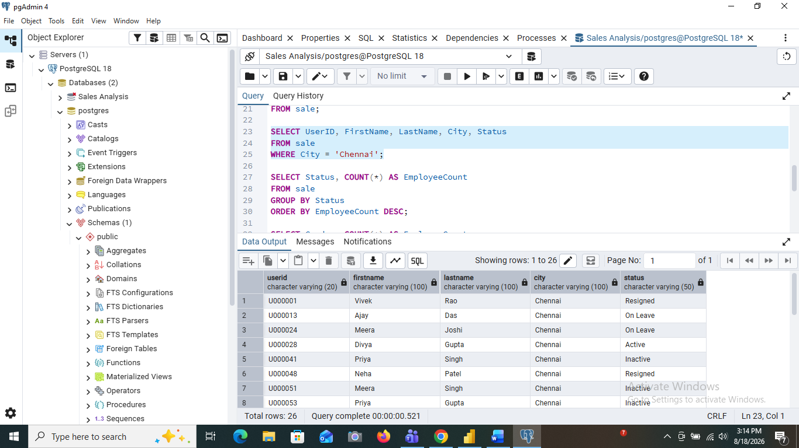

SELECT Status, COUNT(*) AS EmployeeCount
FROM sale
GROUP BY Status
ORDER BY Employee Count DESC;
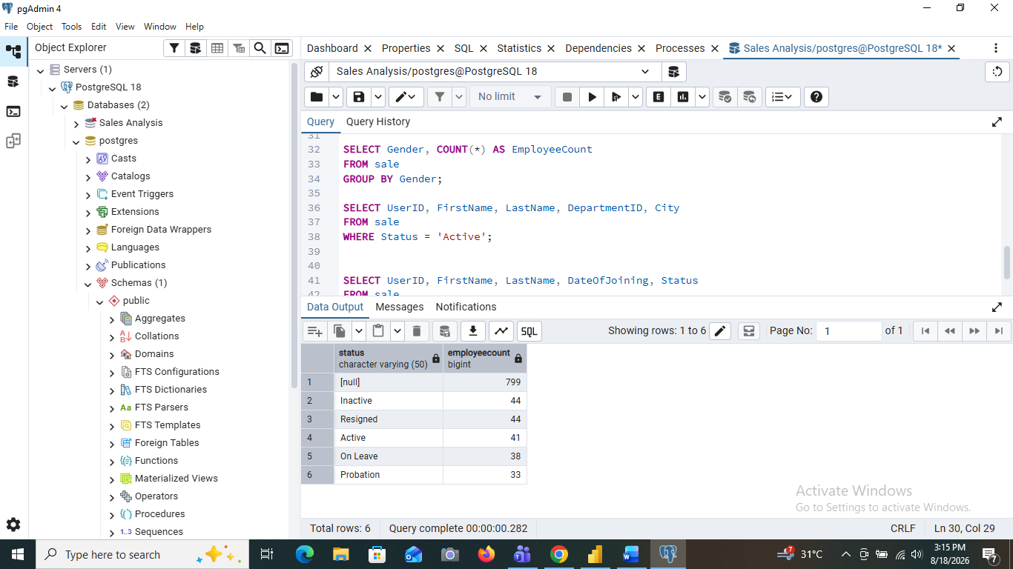

SELECT UserID, FirstName, LastName, DepartmentID, City
FROM sale
WHERE Status = 'Active';
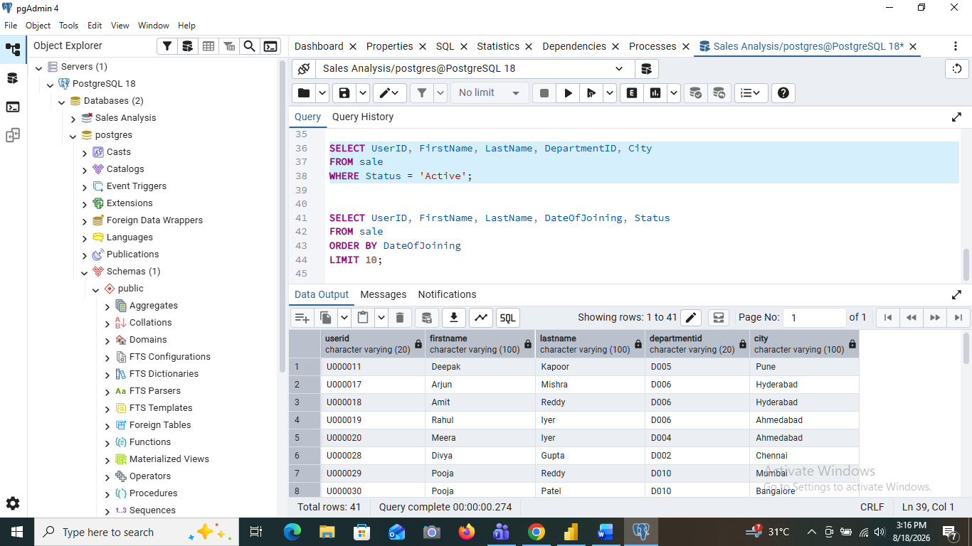

SELECT UserID, FirstName, LastName, DateOfJoining, Status
FROM sale
ORDER BY DateOfJoining
LIMIT 10;
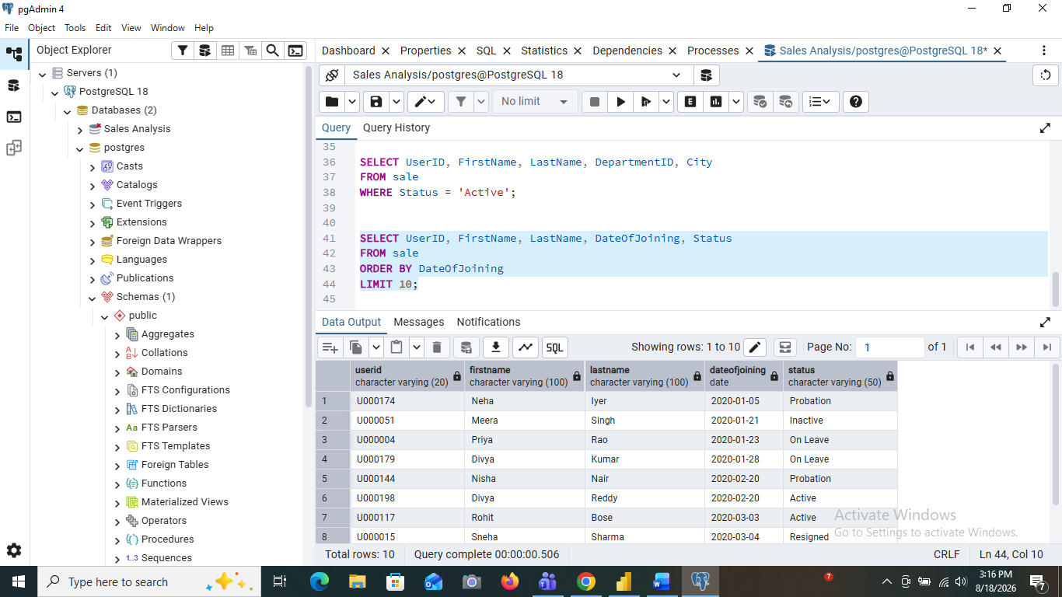

Do some required query in pgadmin after we completed
Move to powerbi for visualization
Step 3: powerbi (Dashboard )
Go to powerbi and click get data (sql)
Enter the connection
Server: localhost:5432
Database: sales_analysis
Enter PostgreSQL credentials
Username: postgres
Password:
Click Connect.
Select your table
sales_analysis
public
└── sales data
Select your table
Powerbi (visual):
Key Business Measures
Measure | Purpose
Sales | Measures revenue generated from sales transactions.
Sales PY | Compares current sales with the previous-year sales value.
Sales vs PY | Shows the variance or comparison between current sales and previous-year sales.
Profit | Measures sales value after deducting the associated cost.
Profit LY | Provides previous-year profit for historical comparison.
Profit Margin | Shows profitability relative to sales.

Dashboard Page 1 – Sales Dashboard
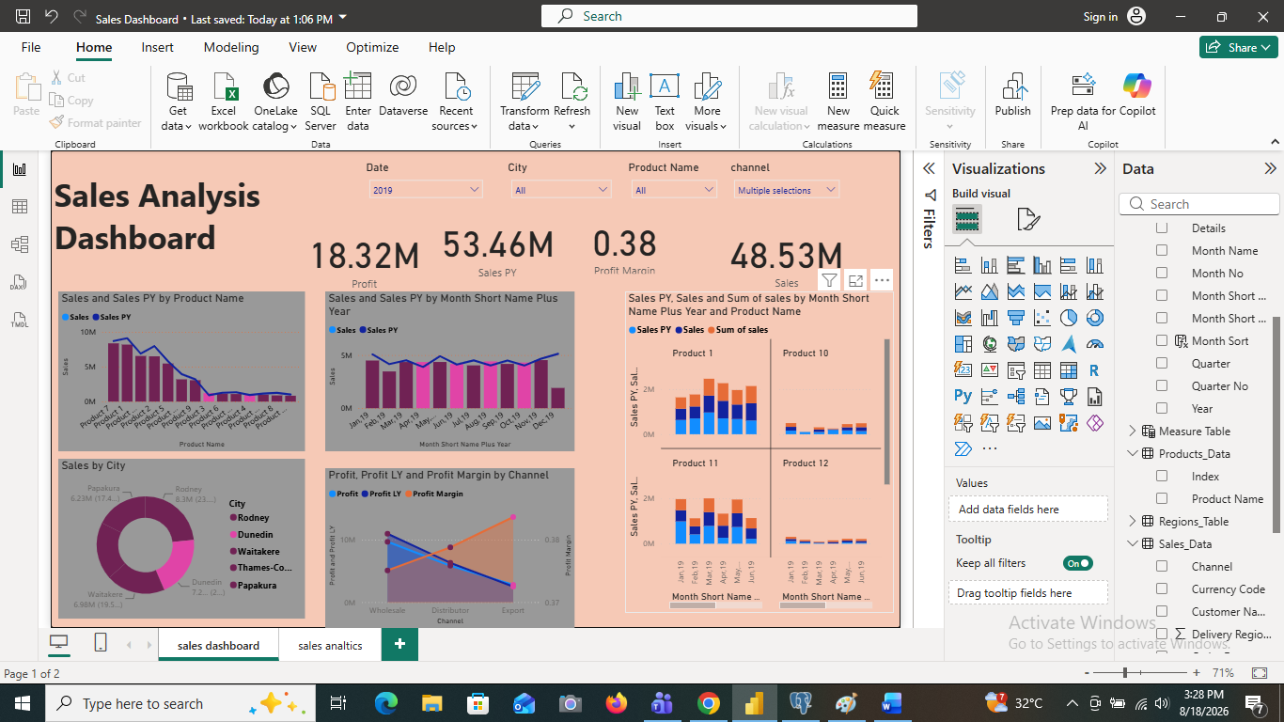

The first report page is designed as the primary management dashboard. It contains four slicers, five analytical charts, and four KPI cards. The slicers allow the user to dynamically filter the report.
Filters / Slicers
Visual | Field | Purpose
Date slicer | DateTable Year / Month-Year | Allows the user to analyze a selected year or month period.
City slicer | Regions_Table City | Filters the dashboard to a selected city.
Channel slicer | Sales_Data Channel | Filters sales by Distributor, Export, Wholesale, or other available channel values.
Product slicer | Products_Data Product Name | Filters the dashboard for a selected product.
Visual 1 – Sales by Product
This combo chart compares current Sales with Sales PY by Product Name and includes Sales vs PY as a comparison measure. It is useful for identifying products with strong growth, weak performance, or a decline compared with the previous year.
Primary dimension: Product Name.
Primary metric: Sales.
Comparison metrics: Sales PY and Sales vs PY.
Business use: product performance and year-over-year comparison.
Visual 2 – Monthly Sales Trend
This line and clustered-column combo chart compares monthly Sales with Sales PY. The Month-Year field is used as the time axis. It helps identify seasonality, growth patterns, and periods where sales are above or below the previous year.
Axis: Month-Year.
Columns/values: Sales and Sales PY.
Line/comparison: Sales vs PY.
Business use: monthly trend and year-over-year monitoring.
Visual 3 – Sales Distribution by City
The donut chart presents Sales by City and provides a quick view of the relative contribution of different cities. It is useful for understanding geographic concentration and identifying major sales markets.
Category: City.
Value: Sales.
Comparison/tooltip measure: Sales vs PY.
Business use: geographic contribution and market concentration.
Visual 4 – Profit by Channel
The area chart analyzes Profit by Channel and includes Profit LY and Profit Margin as supporting measures. It helps compare profitability across sales channels and understand whether higher sales are also producing stronger margins.
Category: Channel.
Primary metric: Profit.
Supporting metrics: Profit LY and Profit Margin.
Business use: channel profitability and margin evaluation.
Visual 5 – Customer Sales Performance
The clustered bar chart compares Sales and Sales PY across customer identifiers. It is intended to highlight high-value customers and customers whose sales have changed compared with the previous year.
Category: Customer Name Index.
Values: Sales and Sales PY.
Comparison: Sales vs PY.
Business use: customer performance and account prioritization
Dashboard Page 2 – Sales Analytics
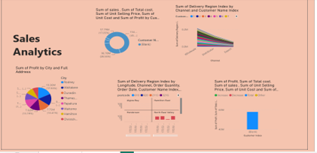
The second page provides deeper analytical views. It contains four visuals covering regional profitability, operational/transaction patterns, channel and customer-region patterns, and profit/cost movement.
Visual 1 – Regional Profit Analysis
The pie chart uses City as the geographic category and Profit as the value. Additional geographic fields such as Full Address, Longitude, Latitude, and Region Index are available to support location-based analysis and tooltips.
Category: City.
Value: Sum of Profit.
Supporting geographic fields: Address, Longitude, Latitude, Region Index.
Business use: identify profitable locations and geographic contribution.
Visual 2 – Regional / Operational Analysis
The line and stacked-column combination visual brings together geography, channel, order quantity, order date, customer, product, and delivery-region information. It can be used to explore how transaction volume and operational activity vary by geography and channel.
Geography: Longitude, postcode, suburb.
Business dimensions: Channel, Customer, Product.
Operational metric: Order Quantity.
Time field: Order Date.
Business use: regional and operational drill-down.
Visual 3 – Channel and Customer/Region Pattern
The stacked area chart compares Channel with aggregated delivery-region information and customer identifiers. Its purpose is exploratory: it helps users inspect how the selected channel and customer groupings are distributed across the available delivery-region values.
Category: Channel.
Supporting fields: Delivery Region Index and Customer Name Index.
Business use: exploratory channel/customer-region segmentation.
Visual 4 – Profit / Cost Waterfall Analysis
The waterfall visual is designed to examine profit movement together with customer, product, cost, sales, shipping date, unit price, unit cost, currency, channel, and delivery-region attributes. It is useful for explaining positive and negative contributions to profitability and for drilling into the drivers behind financial performance.
Primary financial metric: Profit.
Supporting financial fields: Total Cost, Sales, Unit Selling Price, Unit Cost.
Business dimensions: Customer, Product, Channel, Currency, Delivery Region.
Time/operations: Ship Date.
Business use: profit-driver analysis.
Technical Architecture
The recommended project architecture separates data preparation, database storage, and visualization.
Source: Excel → Preparation: Google Colab/Pandas → Storage: PostgreSQL → Database Administration: pgAdmin → Visualization: Power BI Desktop → Dashboard/Reporting.
Conclusion
The Sales Analysis project demonstrates the complete data analytics lifecycle: data ingestion, cleaning, transformation, database loading, analytical modeling, visualization, and business interpretation. The Power BI dashboard is designed to support both high-level KPI monitoring and detailed analysis. The combination of Google Colab, PostgreSQL/pgAdmin, and Power BI provides a practical end-to-end workflow suitable for a Data Analyst portfolio or project submission

